727721EUIT152
SOMA SUNDARI R

DAY 10

TASK :1
package com.Demo.Demo;

import java.util.concurrent.TimeUnit;
import org.openqa.selenium.By;
import org.openqa.selenium.WebDriver;
import org.openqa.selenium.chrome.ChromeDriver;
import org.openqa.selenium.chrome.ChromeOptions;
import org.testng.Assert;
import org.testng.ITestResult;
import org.testng.annotations.AfterMethod;
import org.testng.annotations.AfterTest;
import org.testng.annotations.BeforeClass;
import org.testng.annotations.Test;
import com.aventstack.extentreports.ExtentReports;
import com.aventstack.extentreports.ExtentTest;
import com.aventstack.extentreports.Status;
import com.aventstack.extentreports.reporter.ExtentHtmlReporter;
import com.aventstack.extentreports.reporter.configuration.ChartLocation;
import com.aventstack.extentreports.reporter.configuration.Theme;
import io.github.bonigarcia.wdm.WebDriverManager;

public class d101 {
static ExtentTest test;
static ExtentReports extent;
ExtentHtmlReporter htmlReporter;
@BeforeClass
public void startReport() {
//ExtentSparkReporter htmlReporter = new ExtentSparkReporter("extentReport.html");
//htmlReporter = new ExtentHtmlReporter(System.getProperty("user.dir")+"/test-output/extentReport.html");
htmlReporter = new ExtentHtmlReporter("D:\\testing\\extr_prt1.html");
extent = new ExtentReports();
extent.attachReporter(htmlReporter);

//configuration items to change the look and feel
//add content, manage tests etc
htmlReporter.config().setChartVisibilityOnOpen(true);
htmlReporter.config().setDocumentTitle("Simple Automation Report");
htmlReporter.config().setReportName("Test Report");
htmlReporter.config().setTestViewChartLocation(ChartLocation.TOP);
htmlReporter.config().setTheme(Theme.STANDARD);
// htmlReporter.config().setTimeStampFormat("EEEE, MMMM dd, yyyy, hh:mm a '('zzz')'");
}
@Test
public void f() {
WebDriverManager.chromedriver().setup();
WebDriver driver;
ChromeOptions co = new ChromeOptions();
co.addArguments("--remote-allow-origins=*");
driver=new ChromeDriver(co);
driver.get("https://www.godaddy.com/en-in");
driver.manage().window().maximize();
String actualTitle="Domain Names, Websites, Hosting & Online Marketing Tools - GoDaddy IN";
String extractedTitle=driver.getTitle();
Assert.assertEquals(actualTitle, extractedTitle);
String actualURL="https://www.godaddy.com/en-in";
String extractedURL=driver.getCurrentUrl();
Assert.assertEquals(actualURL, extractedURL);
System.out.println("Smoke test");
driver.quit();
test = extent.createTest("Test Case 1", "The test case 1 has passed");
}

@Test
public void f1() throws Exception {
WebDriverManager.chromedriver().setup();
WebDriver driver;
ChromeOptions co = new ChromeOptions();
co.addArguments("--remote-allow-origins=*");
driver=new ChromeDriver(co);
driver.get("https://www.godaddy.com/en-in");
driver.manage().window().maximize();
driver.navigate().refresh();
//driver.manage().timeouts().implicitlyWait(5, TimeUnit.SECONDS);
//driver.manage().timeouts().implicitlyWait(10,TimeUnit.SECONDS);
Thread.sleep(10);
driver.findElement(By.xpath("//*[@id=\"id-e6aaf13d-272e-44df-903a-e07e539d57c7\"]/span[1]")).click();
//driver.findElement(By.linkText("Domain Name Search")).click();
System.out.println(driver.getTitle());

System.out.println("Regressiontest");
test = extent.createTest("Test Case 2", "The test case 2 has passed");

//driver.quit();
}
@Test
public void f2() {
ChromeOptions co=new ChromeOptions();
co.addArguments("--remote-allow-origins=*");
WebDriverManager.chromedriver().setup();
WebDriver driver=new ChromeDriver(co);
driver.get("https://www.godaddy.com/en-in");
driver.manage().window().maximize();
driver.manage().timeouts().implicitlyWait(10,TimeUnit.SECONDS);
driver.findElement(By.xpath("//*[@id=\"id-631b049a-e9c0-4d24-8710-c504745206dd\"]/div[2]/div[1]/ul/li[1]/button")).click();
driver.findElement(By.xpath("//*[@id=\"id-631b049a-e9c0-4d24-8710-c504745206dd\"]/div[2]/div[1]/ul/li[1]/div/div[2]/div[1]/ul/li[2]/a")).click();
String et="GoDaddy Domain Search - Buy and Register Available Domain Names";
String ct=driver.getTitle();
System.out.println(ct);
Assert.assertEquals(et,ct);
System.out.println("Regressiontest");
test = extent.createTest("Test Case 3", "The test case 3 has passed");

}
@AfterMethod
public void getResult(ITestResult result) {
if(result.getStatus() == ITestResult.FAILURE) {
test.log(Status.FAIL,result.getThrowable());
}
else if(result.getStatus() == ITestResult.SUCCESS) {
test.log(Status.PASS, result.getTestName());
}
else {
test.log(Status.SKIP, result.getTestName());
}
}
@AfterTest
public void tearDown() {
//to write or update test information to reporter
extent.flush();
}
}
CONSOLE OUTPUT:
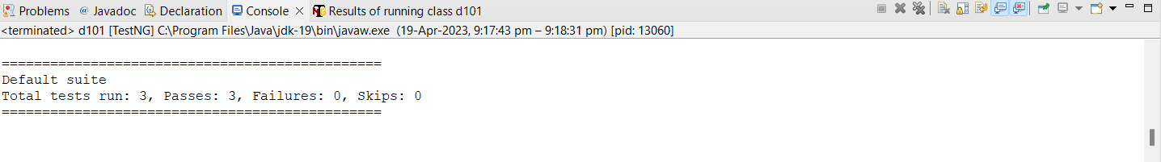
EXTENDED REPORT:
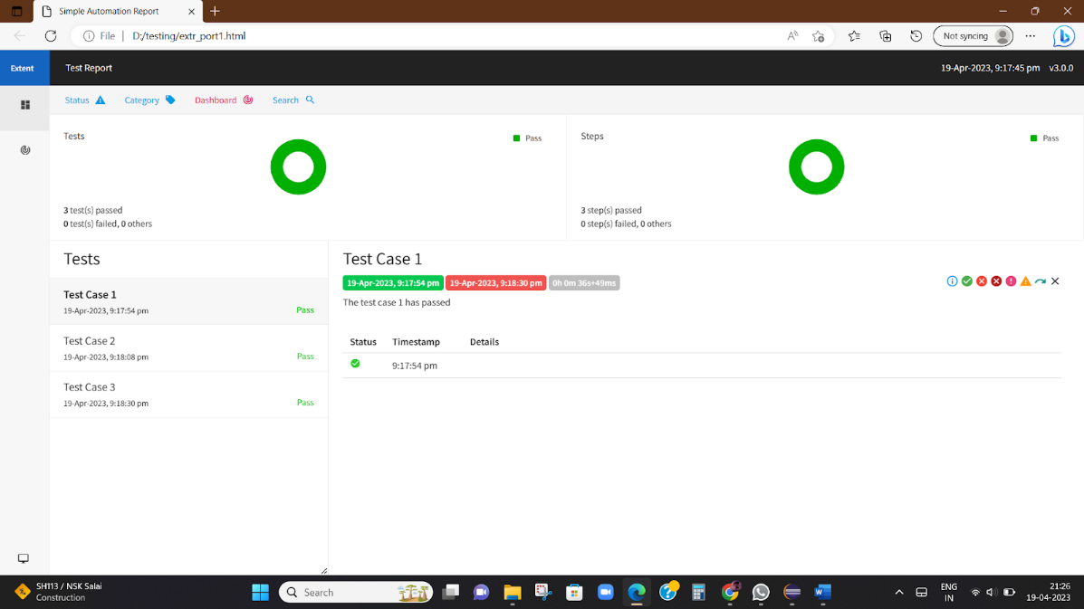

TASK 4:
package com.Demo.Demo;

import org.testng.annotations.Test;

import com.aventstack.extentreports.ExtentReports;
import com.aventstack.extentreports.ExtentTest;
import com.aventstack.extentreports.Status;
import com.aventstack.extentreports.reporter.ExtentHtmlReporter;
import com.aventstack.extentreports.reporter.configuration.ChartLocation;
import com.aventstack.extentreports.reporter.configuration.Theme;

import io.github.bonigarcia.wdm.WebDriverManager;

import org.testng.annotations.BeforeMethod;
import org.openqa.selenium.By;
import org.openqa.selenium.WebDriver;
import org.openqa.selenium.WebElement;
import org.openqa.selenium.chrome.ChromeDriver;
import org.openqa.selenium.chrome.ChromeOptions;
import org.testng.Assert;
import org.testng.ITestResult;
import org.testng.annotations.AfterMethod;
import org.testng.annotations.AfterTest;
import org.testng.annotations.BeforeClass;

public class d104
{
WebDriver driver;
static ExtentTest test;
static ExtentReports extent;
ExtentHtmlReporter htmlReporter;
@BeforeClass
public void startReport()
{
//ExtentSparkReporter htmlReporter = new ExtentSparkReporter("extentReport.html");
//htmlReporter = new ExtentHtmlReporter(System.getProperty("user.dir")+"/test-output/extentReport.html");
htmlReporter = new ExtentHtmlReporter("D:\\testing\\extr_port4.html");
extent = new ExtentReports();
extent.attachReporter(htmlReporter);

//configuration items to change the look and feel
//add content, manage tests etc
htmlReporter.config().setChartVisibilityOnOpen(true);
htmlReporter.config().setDocumentTitle("Simple Automation Report");
htmlReporter.config().setReportName("Test Report");
htmlReporter.config().setTestViewChartLocation(ChartLocation.TOP);
htmlReporter.config().setTheme(Theme.STANDARD);
// htmlReporter.config().setTimeStampFormat("EEEE, MMMM dd, yyyy, hh:mm a '('zzz')'");
}

@Test
public void max_wid() {

WebElement from=driver.findElement(By.xpath("//*[@id=\"app\"]/div[1]/div/div[1]/div/div[2]/div[2]/form/div[1]/div/div[2]/input"));
from.sendKeys("Admin");
WebElement to=driver.findElement(By.xpath("//*[@id=\"app\"]/div[1]/div/div[1]/div/div[2]/div[2]/form/div[2]/div/div[2]/input"));
to.sendKeys("admin123");
WebElement submitBtn=driver.findElement(By.xpath("//*[@id=\"app\"]/div[1]/div/div[1]/div/div[2]/div[2]/form/div[3]/button"));
submitBtn.click();
String CurrentUrl=driver.getCurrentUrl();
String ExpectedUrl="https://opensource-demo.orangehrmlive.com/web/index.php/dashboard/index";
Assert.assertEquals(CurrentUrl, ExpectedUrl);
System.out.println("Smoke test");
driver.quit();
test = extent.createTest("Test Case", "The test case has passed");
}
@BeforeMethod
public void beforeMethod() throws InterruptedException {
WebDriverManager.chromedriver().setup();
ChromeOptions co=new ChromeOptions();
co.addArguments("--remote-allow-origins=*");
driver=new ChromeDriver(co);
driver.get("https://opensource-demo.orangehrmlive.com/web/index.php/auth/login");
driver.manage().window().maximize();
Thread.sleep(3000);
}

@AfterMethod
public void getResult(ITestResult result)
{
if(result.getStatus() == ITestResult.FAILURE)
{
test.log(Status.FAIL,result.getThrowable());
}
else if(result.getStatus() == ITestResult.SUCCESS)
{
test.log(Status.PASS, result.getTestName());
}
else {
test.log(Status.SKIP, result.getTestName());
}
}
@AfterTest
public void tearDown()
{
//to write or update test information to reporter
extent.flush();
}
}

CONSOLE OUTPUT:
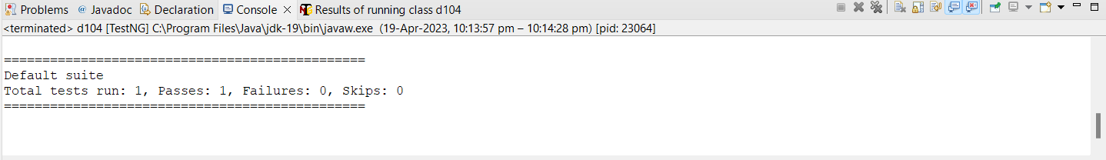
EXTENDED REPORT:
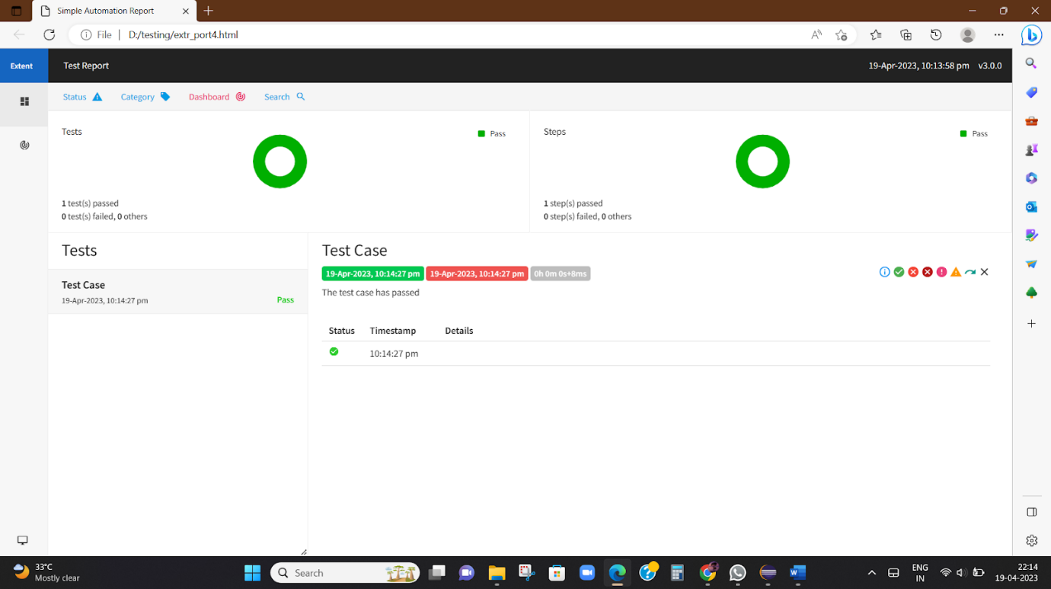

TASK 5:
package com.Demo.Demo;

import org.testng.annotations.Test;
import com.aventstack.extentreports.ExtentReports;
import com.aventstack.extentreports.ExtentTest;
import com.aventstack.extentreports.Status;
import com.aventstack.extentreports.reporter.ExtentHtmlReporter;
import com.aventstack.extentreports.reporter.configuration.ChartLocation;
import com.aventstack.extentreports.reporter.configuration.Theme;
import io.github.bonigarcia.wdm.WebDriverManager;
import org.testng.annotations.BeforeMethod;
import org.openqa.selenium.By;
import org.openqa.selenium.WebDriver;
import org.openqa.selenium.WebElement;
import org.openqa.selenium.chrome.ChromeDriver;
import org.openqa.selenium.chrome.ChromeOptions;
import org.testng.Assert;
import org.testng.ITestResult;
import org.testng.annotations.AfterMethod;
import org.testng.annotations.AfterTest;
import org.testng.annotations.BeforeClass;

public class d105
{
WebDriver driver;
static ExtentTest test;
static ExtentReports extent;
ExtentHtmlReporter htmlReporter;
@BeforeClass
public void startReport()
{
htmlReporter = new ExtentHtmlReporter("D:\\testing\\extr_port5.html");
extent = new ExtentReports();
extent.attachReporter(htmlReporter);
htmlReporter.config().setChartVisibilityOnOpen(true);
htmlReporter.config().setDocumentTitle("Simple Automation Report");
htmlReporter.config().setReportName("Test Report");
htmlReporter.config().setTestViewChartLocation(ChartLocation.TOP);
htmlReporter.config().setTheme(Theme.STANDARD);
}

@Test
public void max_wid()
{
WebElement from=driver.findElement(By.xpath("//*[@id=\"app\"]/div[1]/div/div[1]/div/div[2]/div[2]/form/div[1]/div/div[2]/input"));
from.sendKeys("Suvitha");
WebElement to=driver.findElement(By.xpath("//*[@id=\"app\"]/div[1]/div/div[1]/div/div[2]/div[2]/form/div[2]/div/div[2]/input"));
to.sendKeys("12345");
WebElement submitBtn=driver.findElement(By.xpath("//*[@id=\"app\"]/div[1]/div/div[1]/div/div[2]/div[2]/form/div[3]/button"));
submitBtn.click();
String CurrentUrl=driver.getCurrentUrl();
String ExpectedUrl="https://opensource-demo.orangehrmlive.com/web/index.php/auth/login";
Assert.assertEquals(CurrentUrl, ExpectedUrl);
System.out.println("Smoke test");
driver.quit();
test = extent.createTest("Test Case", "The test case has passed");
}
@BeforeMethod
public void beforeMethod() throws InterruptedException
{
WebDriverManager.chromedriver().setup();
ChromeOptions co=new ChromeOptions();
co.addArguments("--remote-allow-origins=*");
driver=new ChromeDriver(co);
driver.get("https://opensource-demo.orangehrmlive.com/web/index.php/auth/login");
driver.manage().window().maximize();
Thread.sleep(3000);
}

@AfterMethod
public void getResult(ITestResult result)
{
if(result.getStatus() == ITestResult.FAILURE)
{
test.log(Status.FAIL,result.getThrowable());
}
else if(result.getStatus() == ITestResult.SUCCESS)
{
test.log(Status.PASS, result.getTestName());
}
else {
test.log(Status.SKIP, result.getTestName());
}
}
@AfterTest
public void tearDown()
{
extent.flush();
}
}

CONSOLE OUTPUT:
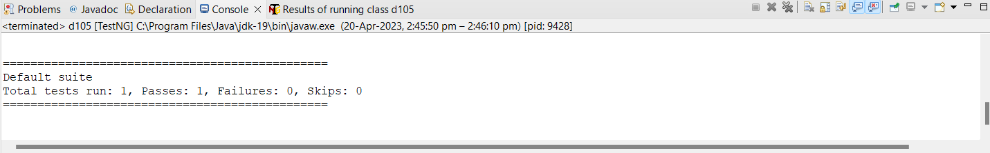

EXTENDED REPORT:
